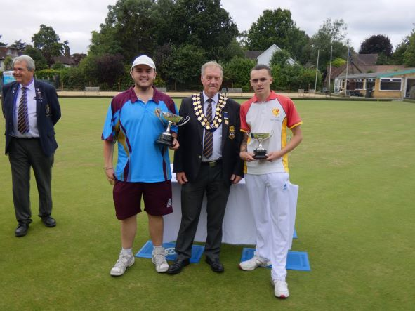 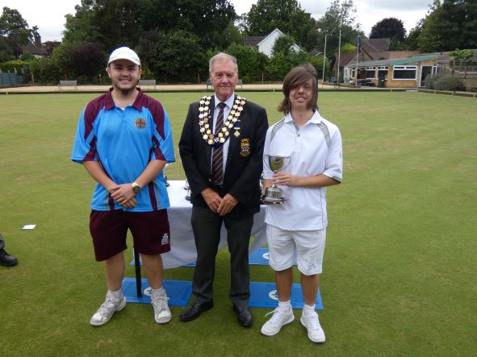

Junior Singles Winner Josh McCarthy - Camberley Junior Pairs Winners George Hopper - Newdigate

Finalist Ryan Bickley – Bletchingley Josh McCarthy – Camberley

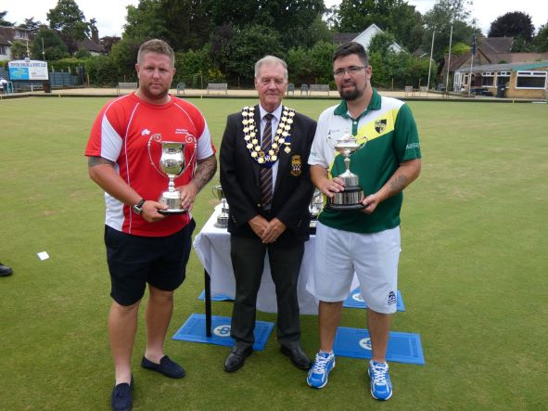 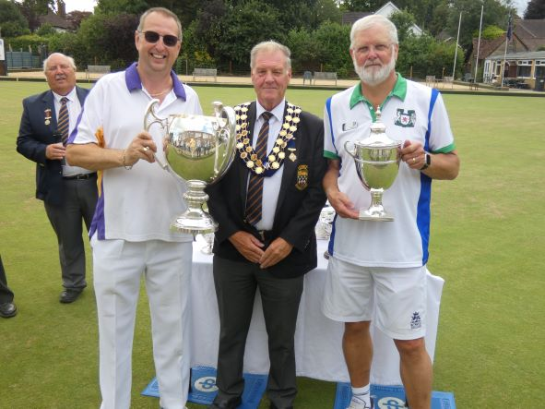

Four wood Singles Winner Paul Jenkins – Wandiliea Unbadged Singles Winner Michael Kerby – Malden Manor

Finalist Nathan Beeson – Old Dean Finalist Nick Anderson – Burpham

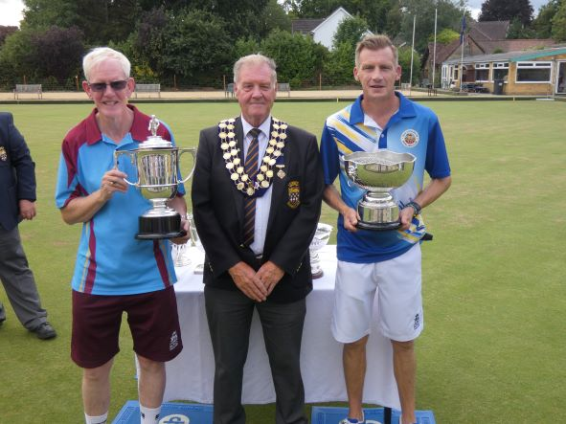 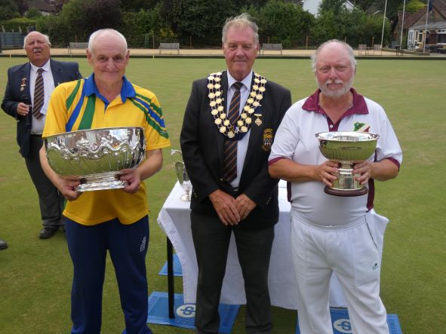

C of C Winner David McCallum – Camberley Officers Bowl Winner Roy Spencer - Egham

Finalist Simon Clarke – Old Coulsdon Finalist Tony Buckee – Horley

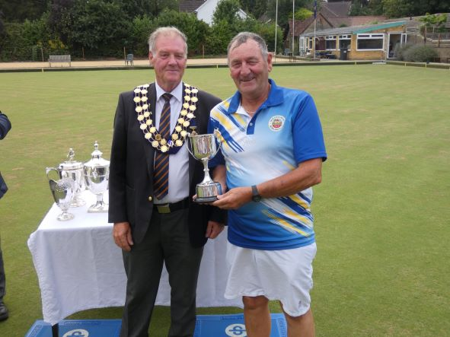 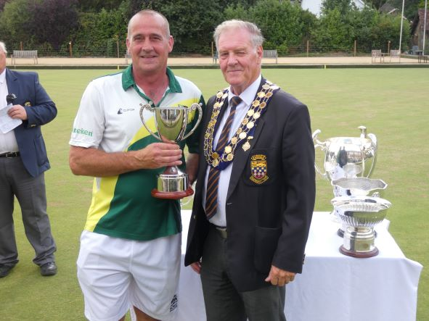

Two-Wood Finalist Andrew Barclay – Old Coulsdon Two-Wood Winner Anthony Reynolds – Old Dean

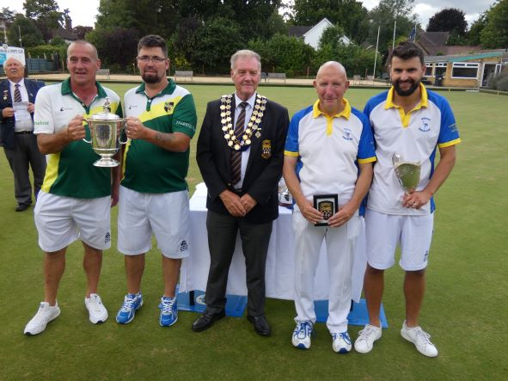 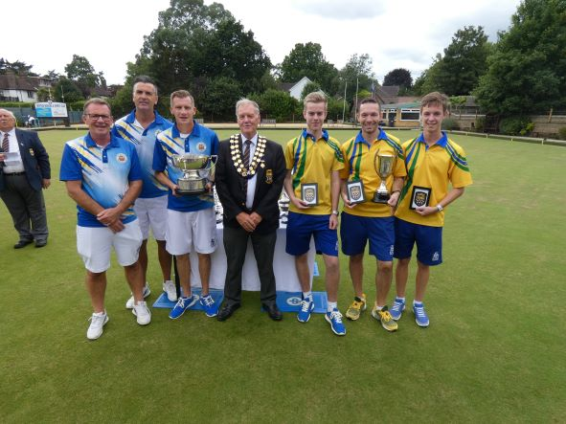

Pairs Winners – Old Dean Triples Winners – Old Coulsdon

Anthony Reynolds & Nathan Beeson James Cooper, Paul Bennett & Simon Clarke

Finalists – Cranleigh Finalists - Egham

David Andrews & James Freemantle Oliver Stonehill, Will Vizer-Allen & Joshua Tiffin

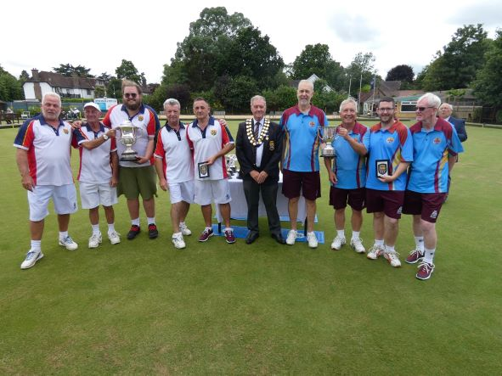 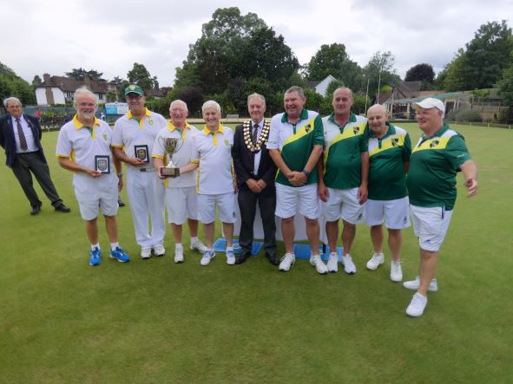

Fours Winners – Belmont Senior Fours Winners – Epsom Park

Richard Corne, Chris Cummins, Russell Stanley Stefan Lukatschat, Ian Dixon, Chris Jones & Jeff O’Leary

& Don Leach. Joshua Hawkins (Reserve)

Finalists – Camberley Finalists – Old Dean

Tony Woolf, Michael Dray, Martin Sampson Chris Turner, Richard Webb, Anthony Reynolds

& David McCallum & Kevin Clarke