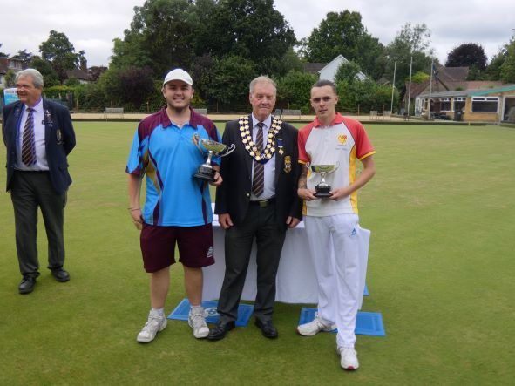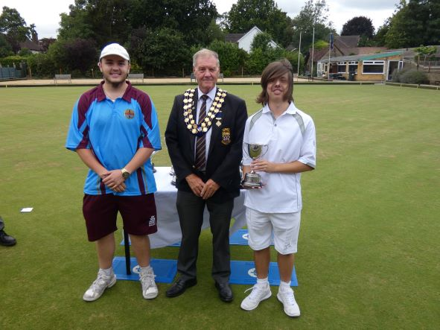
Junior Singles Winner Josh McCarthy - Camberley Junior Pairs Winners George Hopper - Newdigate
Finalist Ryan Bickley – Bletchingley Josh McCarthy – Camberley
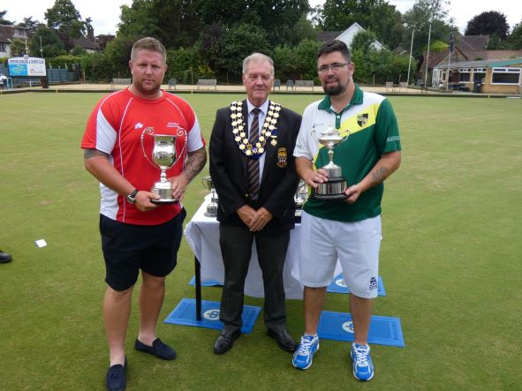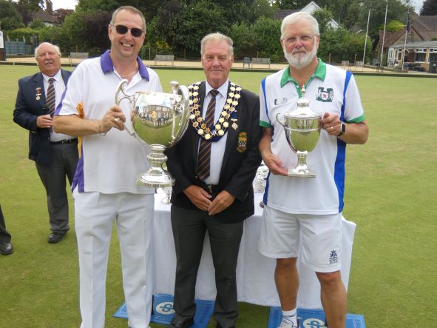
Four wood Singles Winner Paul Jenkins – Wandiliea Unbadged Singles Winner Michael Kerby – Malden Manor
Finalist Nathan Beeson – Old Dean Finalist Nick Anderson – Burpham
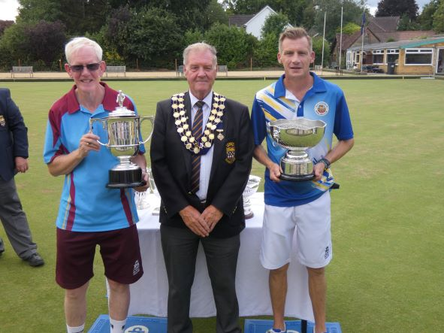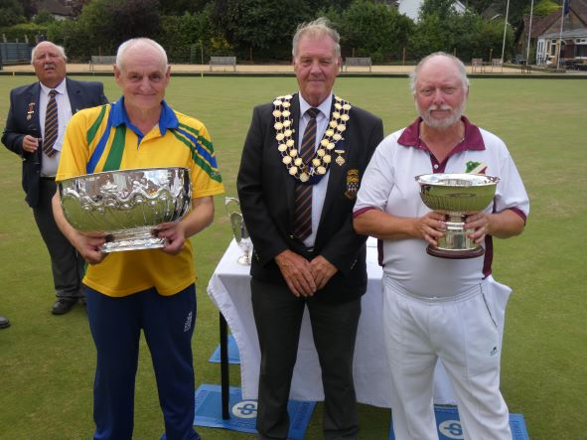
C of C Winner David McCallum – Camberley Officers Bowl Winner Roy Spencer - Egham
Finalist Simon Clarke – Old Coulsdon Finalist Tony Buckee – Horley
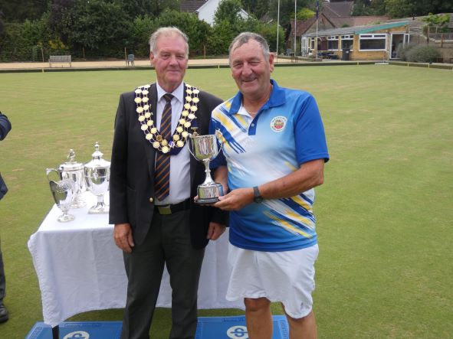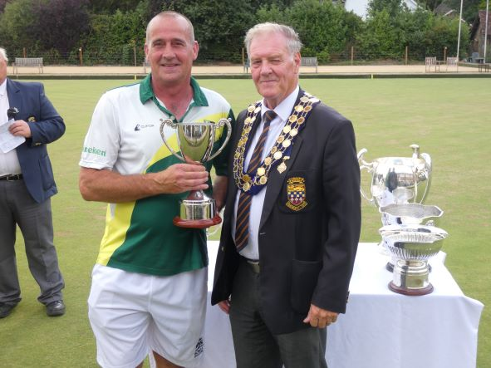

Two-Wood Finalist Andrew Barclay – Old Coulsdon Two-Wood Winner Anthony Reynolds – Old Dean
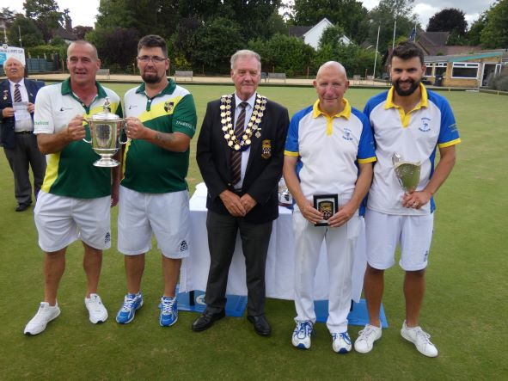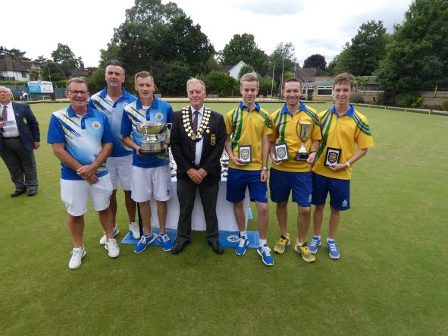
Pairs Winners – Old Dean Triples Winners – Old Coulsdon
Anthony Reynolds & Nathan Beeson James Cooper, Paul Bennett & Simon Clarke
Finalists – Cranleigh Finalists - Egham
David Andrews & James Freemantle Oliver Stonehill, Will Vizer-Allen & Joshua Tiffin
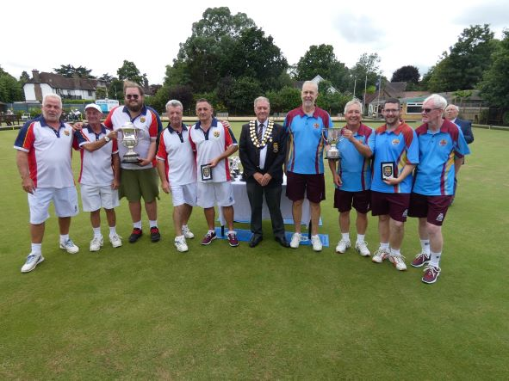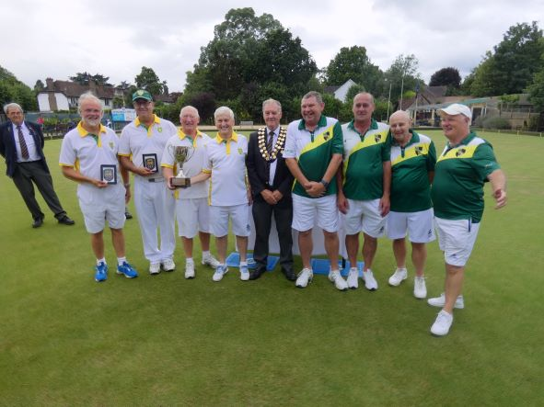
Fours Winners – Belmont Senior Fours Winners – Epsom Park
Richard Corne, Chris Cummins, Russell Stanley Stefan Lukatschat, Ian Dixon, Chris Jones & Jeff O’Leary
& Don Leach. Joshua Hawkins (Reserve)
Finalists – Camberley Finalists – Old Dean
Tony Woolf, Michael Dray, Martin Sampson Chris Turner, Richard Webb, Anthony Reynolds
& David McCallum & Kevin Clarke

