HOW TO LOGIN TO THE BOWLS SURREY WEBSITE AND ONLINE SYSTEM
Website.
To access the website, enter
www.bowlssurrey.co.uk or www.scbamatch.co.uk
The website has two parts to it “Public” & “Members”.
The “Public” pages are open to anyone who accesses the website, to access the “members” pages you have to login, only “Affiliated members” will have access to the members pages.
Please note: if you login via www.bowlssurrey.co.uk
In the top right-hand corner of the “tab” line on the website you will see the tab “online”
Click on this tab. If you are already a user of the online system for Competitions & County matches, please use your existing login details.
If you have never logged in before, click on the tab, you will get the following screen: -
Please note: if you login via www.scbamatch.co.uk it will take you straight to this screen.
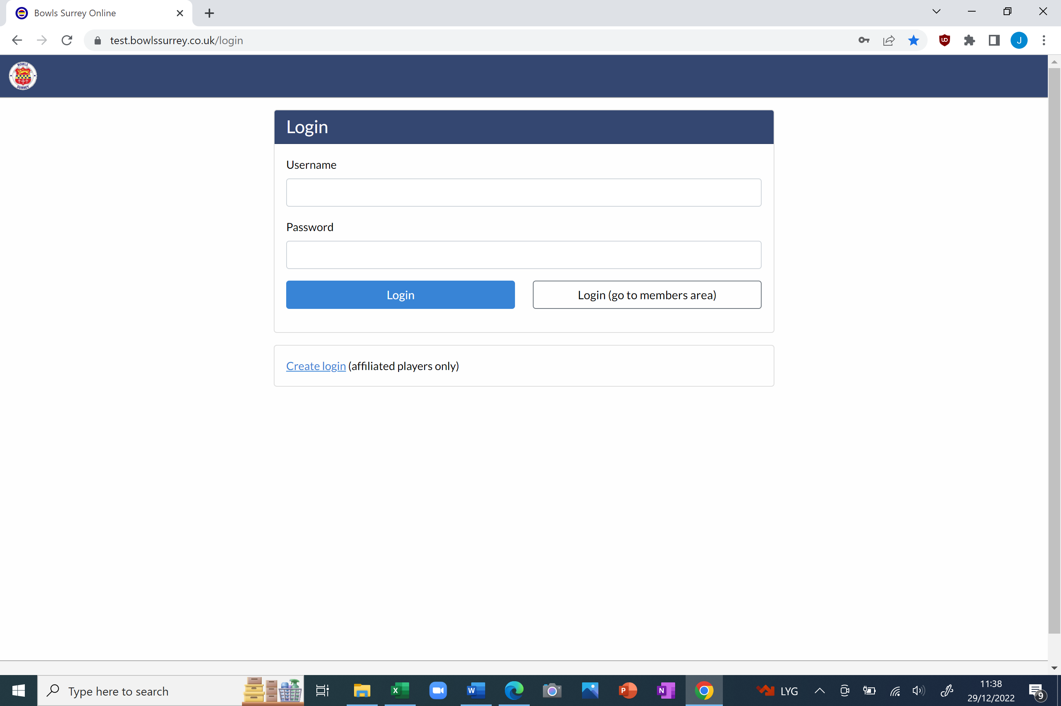
Click where it says “CREATE LOGIN” you will then get the following screen: -
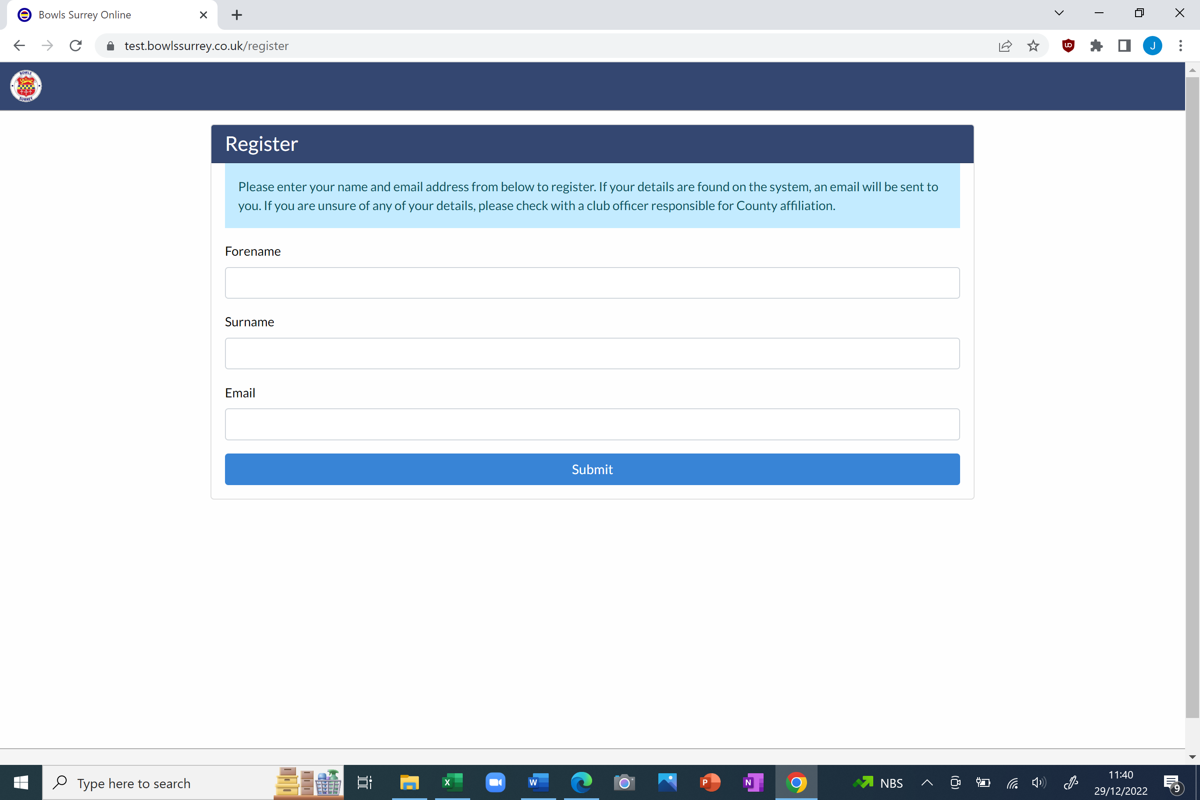
Enter your details, if your details match what your club secretary has entered at affiliation, an email will be sent to you, open the email, and follow the instructions.
If you do not get an email, please contact John Tucker either by email at secretary@surreycountybowls.co.uk or phone 07846 367034.
Once you are logged in you can access both the online system and the “members “ pages of the website, by just clicking the “website” tab in top right-hand corner of the “tab” line. See below: -
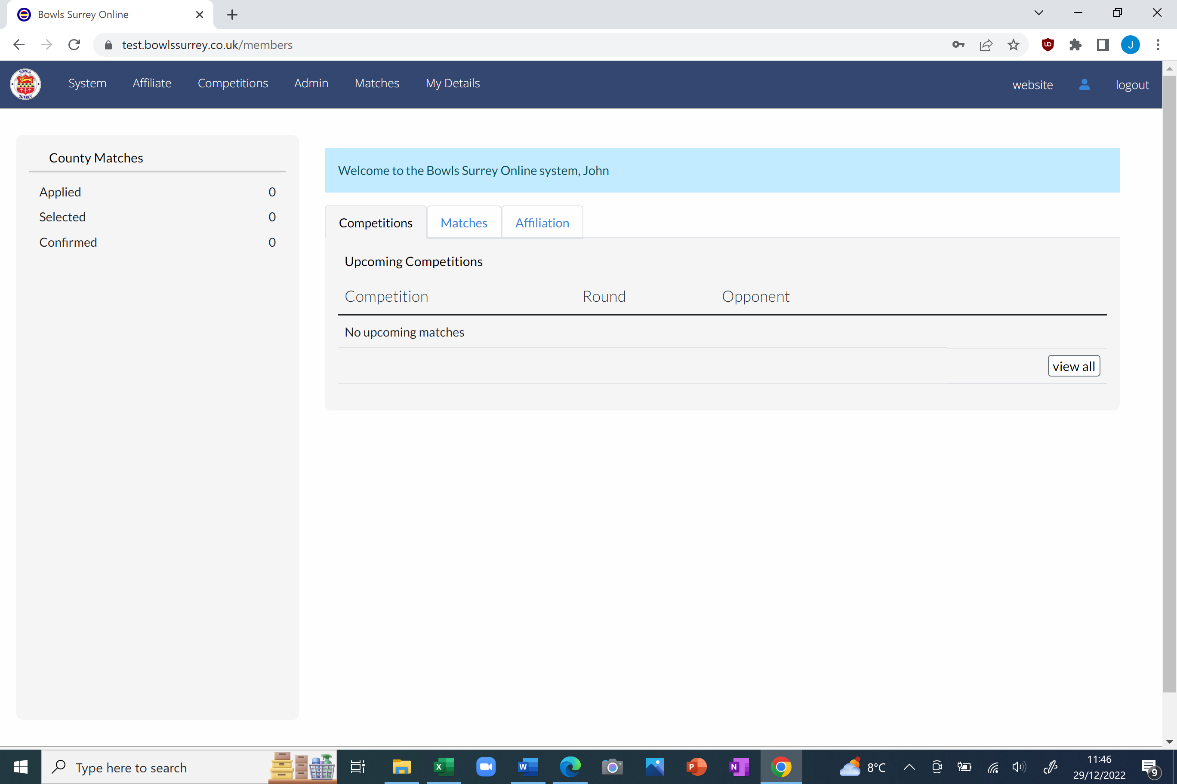
This will take you to the “public” home page, See below: -
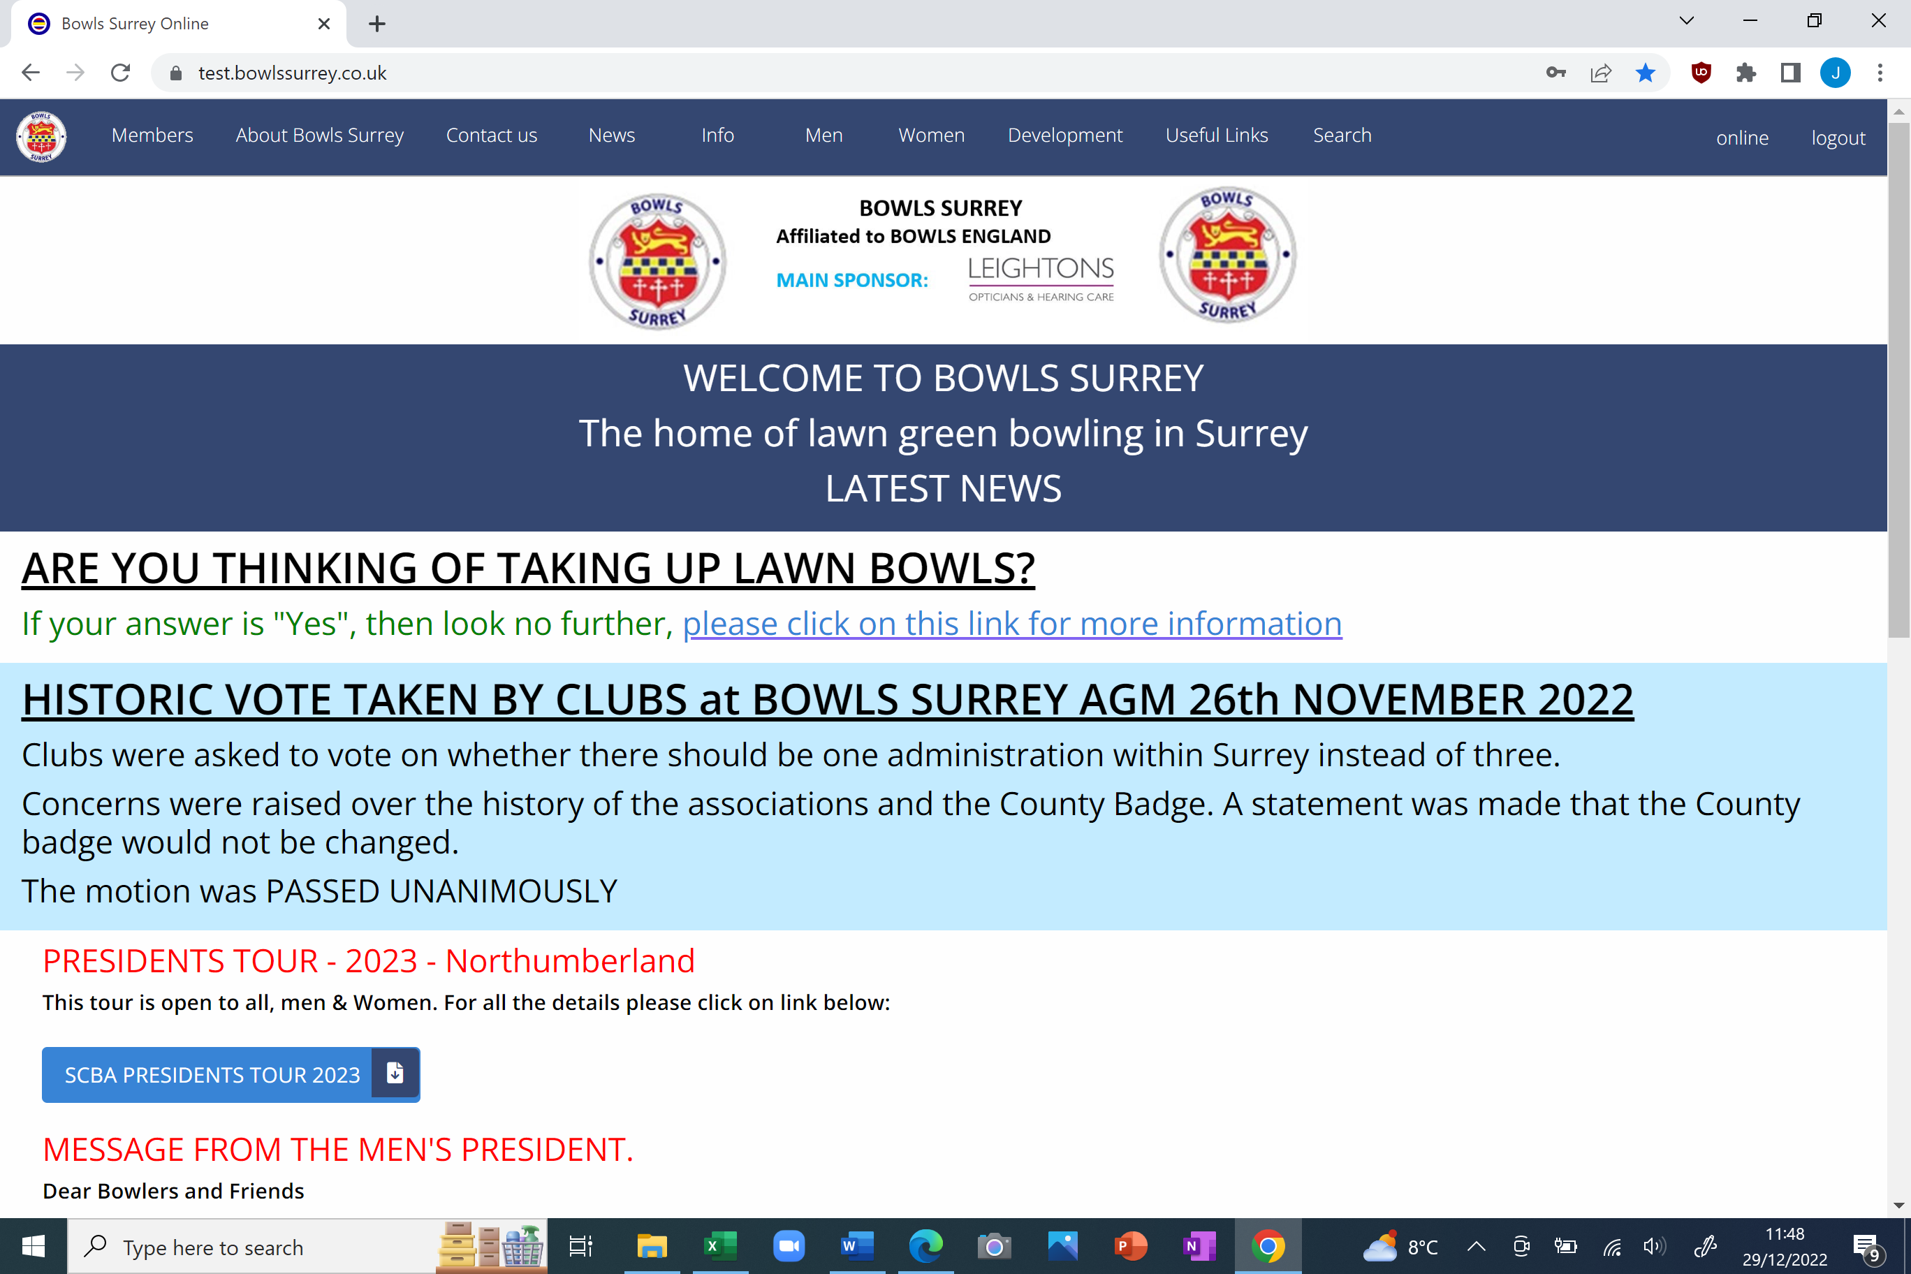
Then by clicking on the “members” on the “tab” line in the top left-hand side you have access to the “members” pages on the website. See below: -
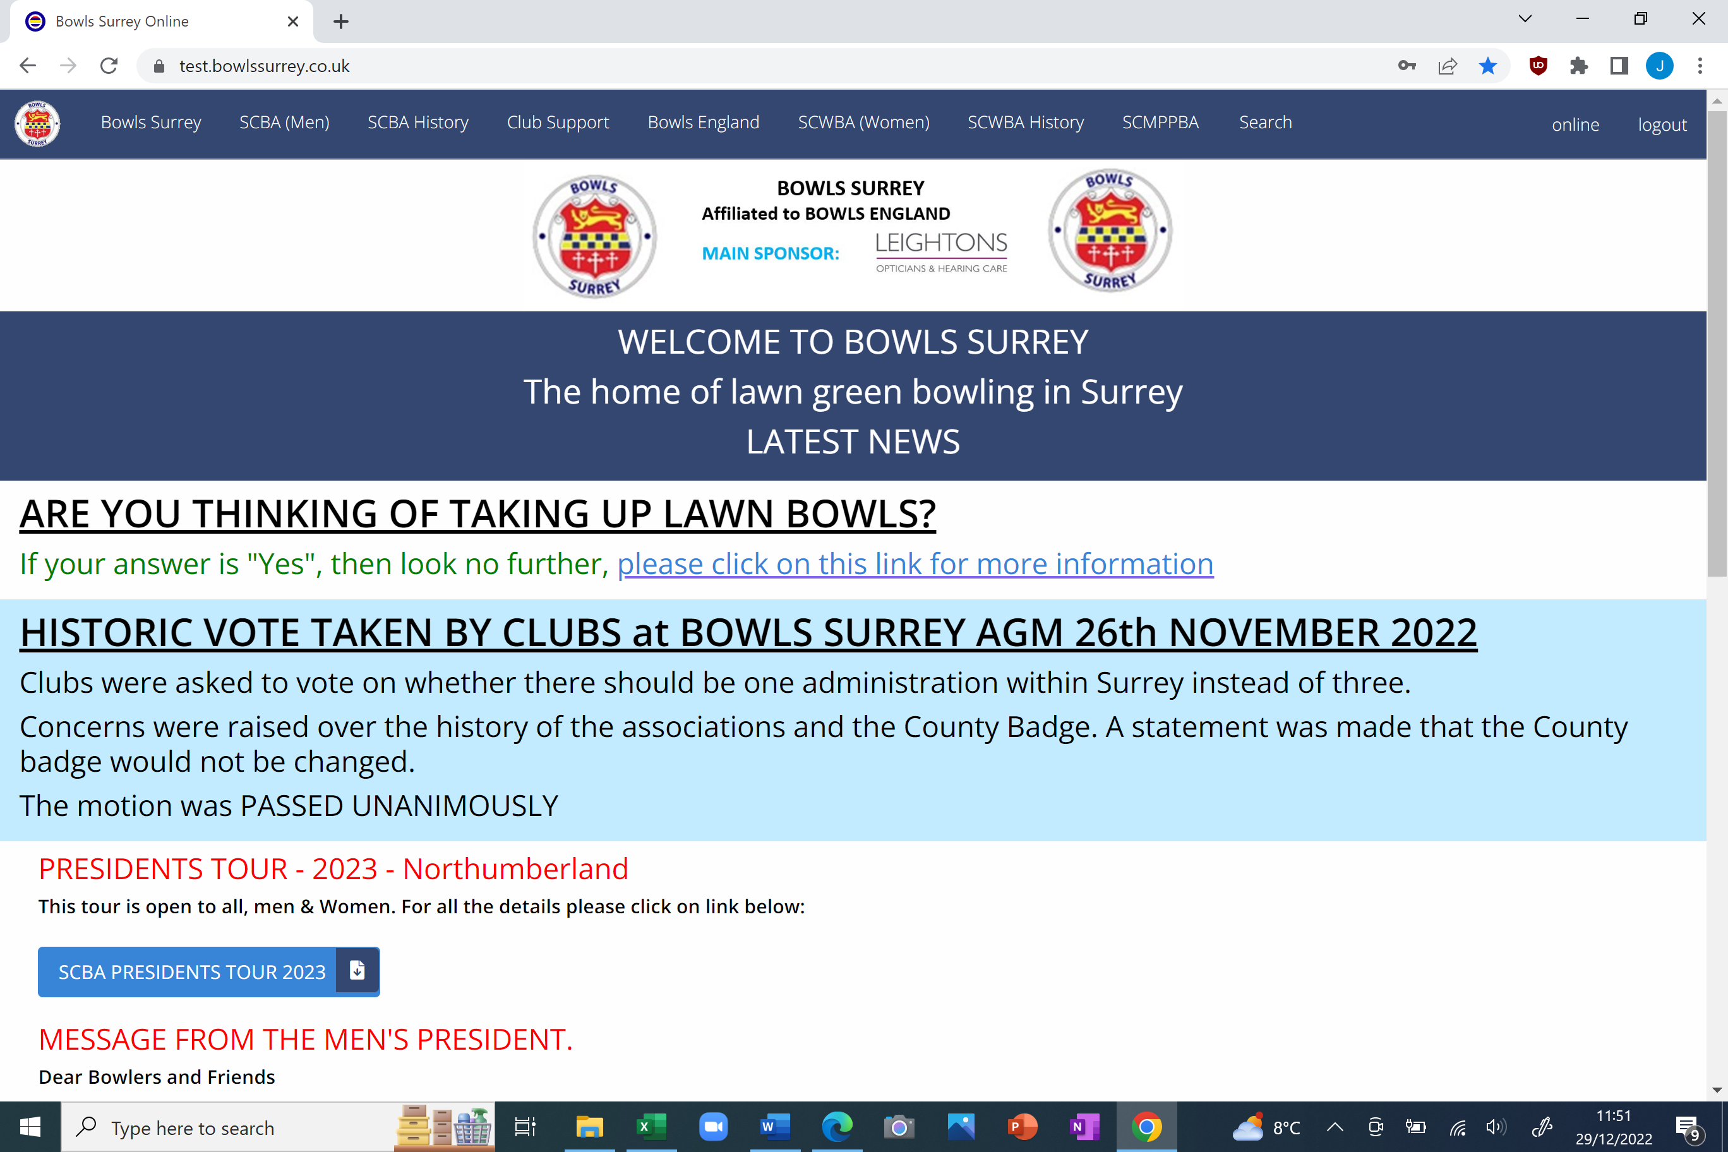
You will notice that the “home” page is the same, but the “tabs” are different.
Finally.
If you click on any of the tabs whether it be public or members if will give you a dropdown of categories, with hopefully all the information required, please see example below having clicked on the “club support tab: -
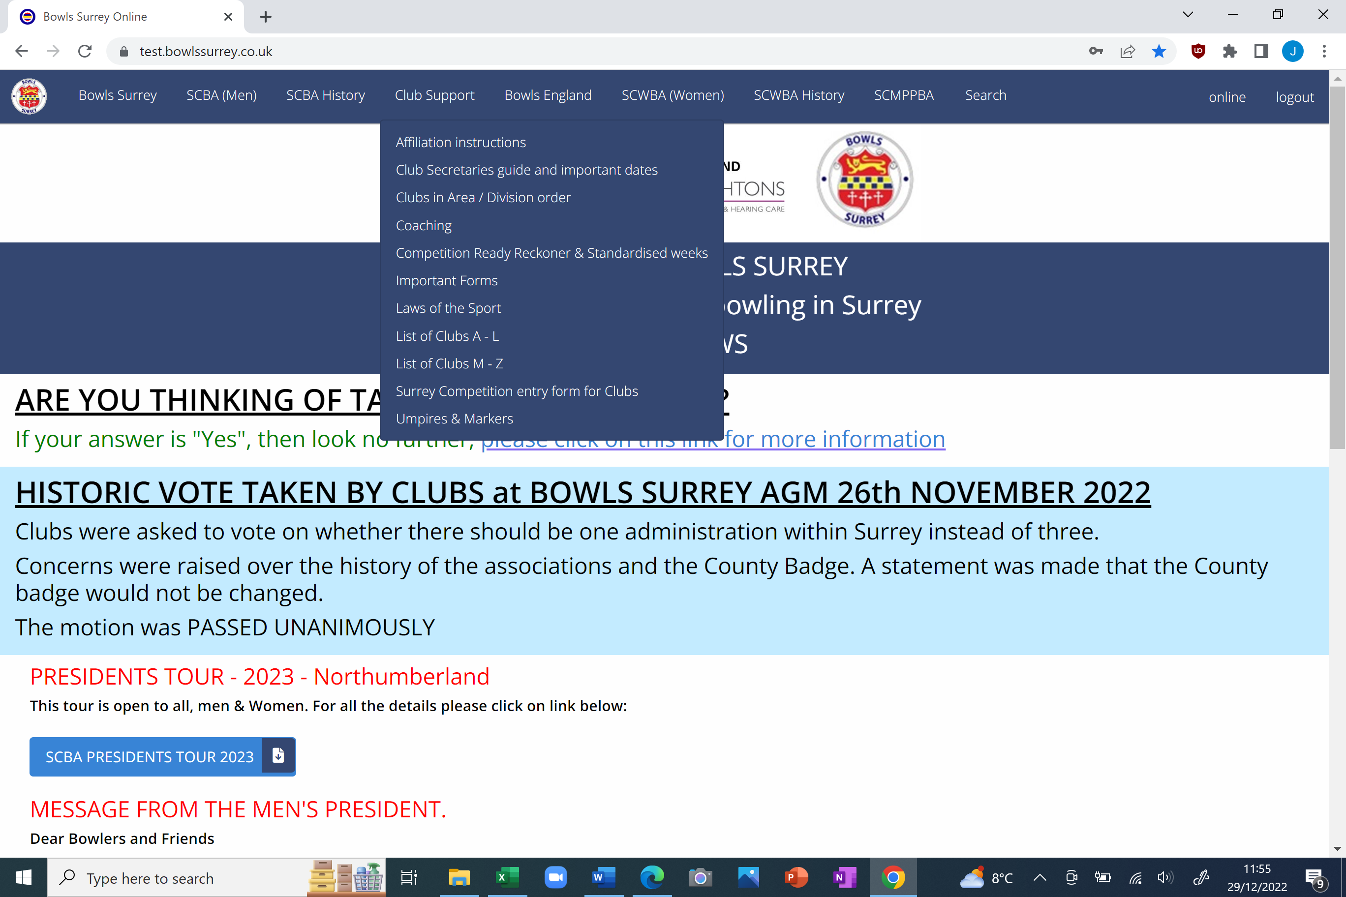
Any queries you may have regarding both the website or online systems, please contact John Tucker by EMAIL secretary@surreycountybowls.co.uk

