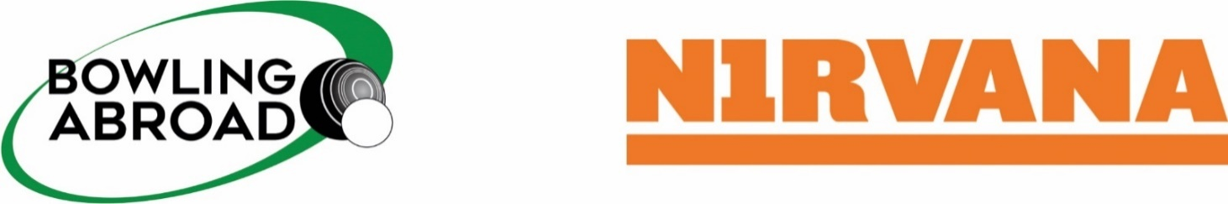

**SURREY COUNTY PRESIDENTS TOUR**

**Algarve Bowls Tour – 1st October 2024**

Hotel Dom Jose Beach. 7 night’s HB, 4 games of bowls

**Return flights from Gatwick airport to Faro airport with 23kg luggage to be added at cost**

**PLEASE TICK THE BOX FOR YOUR REQUEST**

**Sharing twin sea view rooms with balcony £695.00 per person **

**Sharing twin city view rooms with NO balcony - £660.00 per person **

**Twin front sea view rooms with balcony for single use - £975.00 per person **

**Twin city view rooms with NO balcony for single use - £875.00 per person **

**NAME:**

**ADDRESS: POST CODE:**

**PHONE NUMBER: EMAIL:**

**PASSPORT DETAILS AS PER PASSPORT**

|  |  |  |
| --- | --- | --- |
|  | **1st Named Passenger** | **2nd Named Passenger (if applicable)** |
| **Mr/Mrs:** |  |  |
| **First Name:** |  |  |
| **Surname:** |  |  |
| **Passport No:** |  |  |
| **Issue Date:** |  |  |
| **Expiry Date:** |  |  |
| **Date of Birth:** |  |  |
| **Nationality:** |  |  |
| **Bowler/Non-Bowler: Y/N** | **YES / NO** | **YES / NO** |

**SPECIAL REQUIREMENTS:**

**Payment by bank transfer to: NIRVANA – A/C: 00866393 / Sort Code: 20-23-81 / Ref: SURREY**

**Card payment call Helen Fletcher @ Nirvana 0191 257 1750**

**Deposit £250 by 1st December 2023 ~ Balance 12 weeks before travel**

**Cancellation by the customer**, If you, or any of your party need to cancel, we must be advised ASAP in writing, cancellation charges as outlined below will apply, you may substitute party members, with any flight amendment charges payable

* More than 84 days before departure: loss of deposit paid or due
* Less than 84 days before departure: up to 100% of the package price
* Flight booking at anytime: loss of amount paid for flight
* If cancellation is of ill health, we will supply your insurance company with an invoice for a full refund from them

|  |  |  |
| --- | --- | --- |
| **BOWLS AVAILABLE TO HIRE IN THE ALGARVE**  **£15 a pair (save on luggage weight) please circle if required** | **SIZE: 0 1 2 3 4 5** | **WEIGHT H or M** |
|  |  |  |
| **BOWLS AVAILABLE TO HIRE IN THE ALGARVE**  **£15 a pair (save on luggage weight) please circle if required** | **SIZE: 0 1 2 3 4 5** | **WEIGHT H or M** |