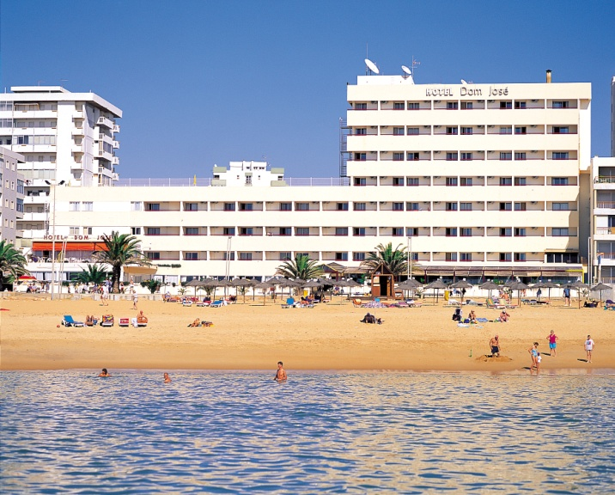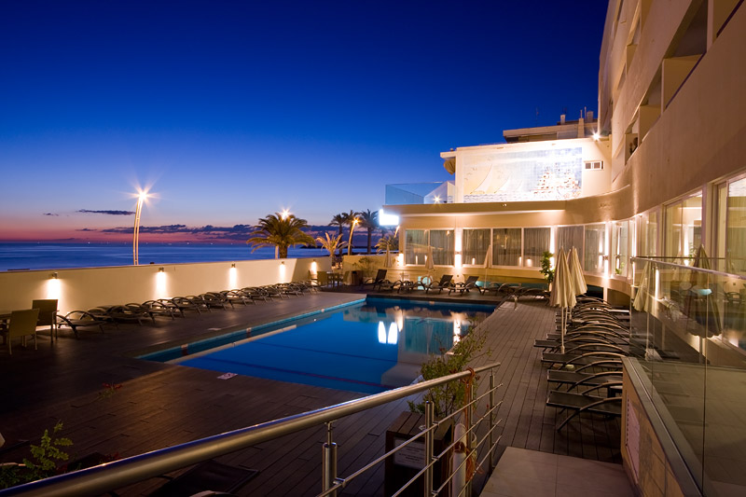

****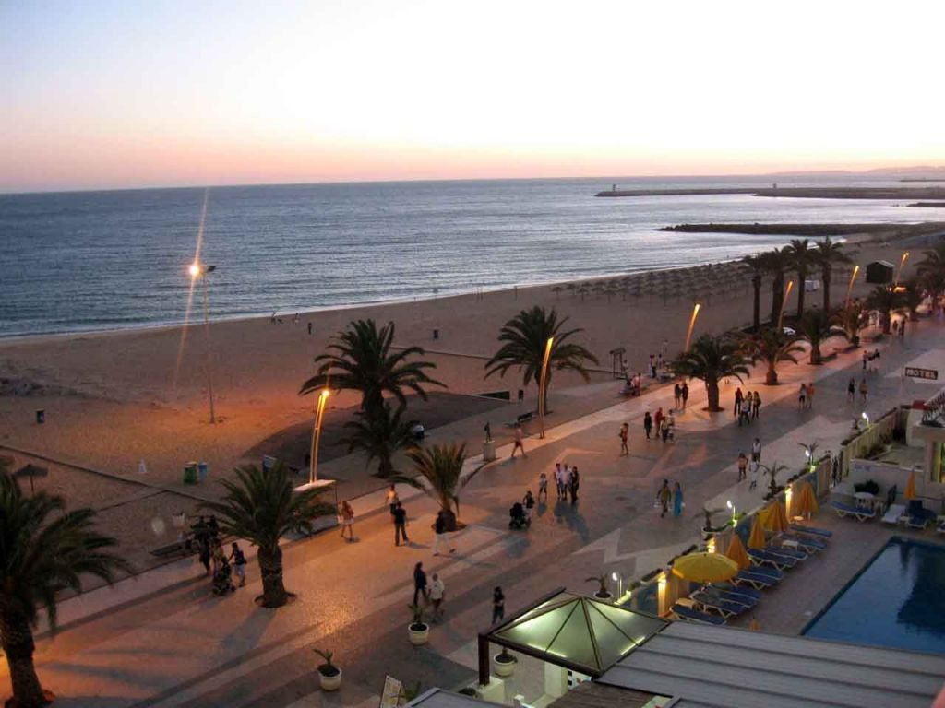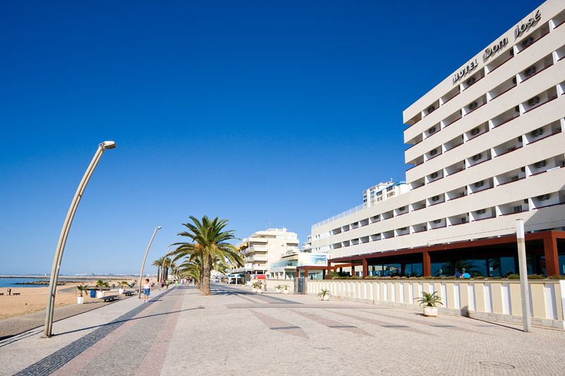

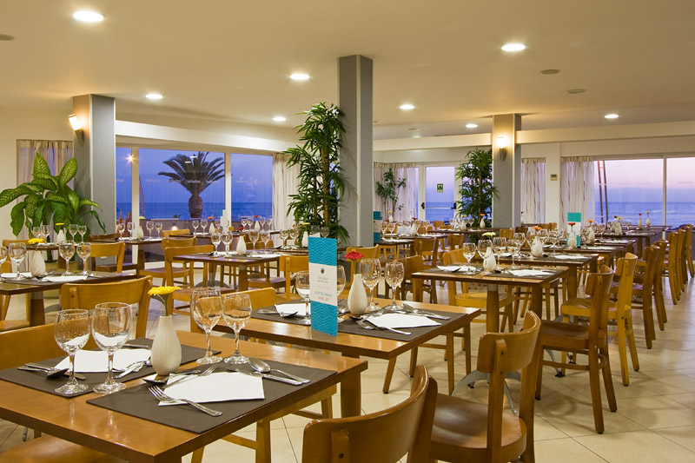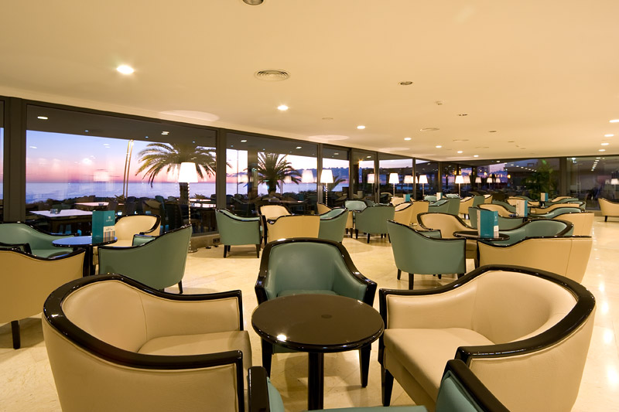

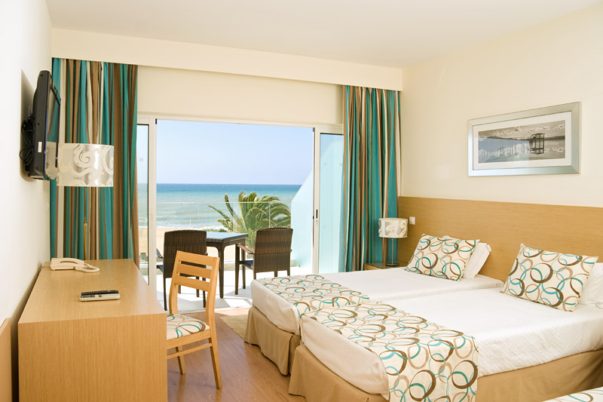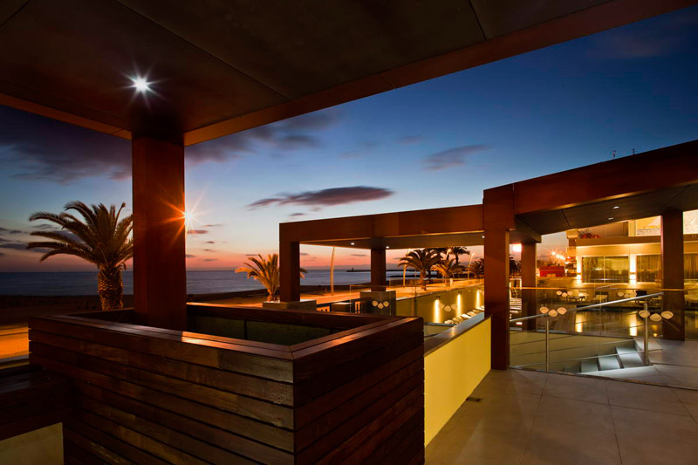

**Hotel Dom Jose Beach – Algarve**

Situated in an enviable beach front with stunning views of the azure Atlantic Ocean and golden sands, the Hotel Dom Jose Beach is the ideal base for a bowling holiday. With plenty of shops, bars and restaurants nearby, the Hotel Dom Jose Beach boasts an abundance of amenities and is our fastest selling hotel in the Algarve.

Completely renovated in 2011 the hotel offers comfortable modern rooms, stylishly decorated in natural colours, wood flooring, modern furniture, and equipped with air-conditioning, LCD TV, private bathroom and mini-bar.

The trendy restaurant offers a buffet service with a good choice of with mouth-watering cuisine, with a meat, fish and vegetarian option, along with soup and side dishes. Breakfast will set you up for the day with a great selection of cereals, breads and cold meats as well as a hearty cooked breakfast menu.

The contemporary Salao lounge bar serves wide range of drinks and leads to an outside terrace facing the exquisite Atlantic Ocean and overlooking the freshwater outside swimming pool; the perfect place to meet up for the nightly happy hour with your group to watch the amazing sunsets.

The long flat promenade facilitates enjoyable walks, with Vilamoura being only a 20-minute stroll where you will find the famous marina and the fabulous casino, which also presents fabulous shows in the evenings! For the more active there is bicycle hire and a fully equipped gym!

There is also free Wi-Fi in public areas, 24-hour reception, secure card entry direct onto the promenade and the happy welcoming staff are always on hand to help you make the most out of your holiday.

The working town of Quarteira has everything you could possibly need! There is a weekly Wednesday gypsy market which is very popular and the ideal place to buy unique presents for loved ones, or indeed yourself! The town has many boutique shops and the hotel is almost opposite the main bus station, where the buses travel all over the Algarve.

**Quote Reference: Surrey County Presidents Tour**

**1st October 2024 Dom Jose Beach Hotel 7 nights**

* **Return flights to be added at cost we make no profit from them.**
* Staying in front sea view twin rooms with balconies on Half Board
* One free drink with meal, wine, or water
* One night out at La Cabane local restaurant
* 4 games of bowls at specially selected bowls greens
* 2 half day excursions on match days if required
* Includes all green fees
* Private return transfers between the airport and hotel, & from hotel to all bowls clubs
* You will be met at the airport by our bowls tour manager, who will escort you to your hotel and bowls matches and be available throughout your tour
* Welcome gifts & top rink prizes
* All tours are covered by ATOL & ABTA

**Total Price based on 20+ persons for 7 nights on half board.**

* **Sharing twin front sea view rooms with balcony - £695.00 per person on Half Board**
* **Sharing twin city view rooms with NO balcony - £660.00 per person on Half Board**
* **Twin front sea view rooms with balcony for single use - £975.00 per person on Half Board**
* **Twin city view rooms with NO balcony for single use - £875.00 per person on Half Board**

**FLIGHTS TO BE ADDED AT COST**