FINALS DAY PHOTOS 2025
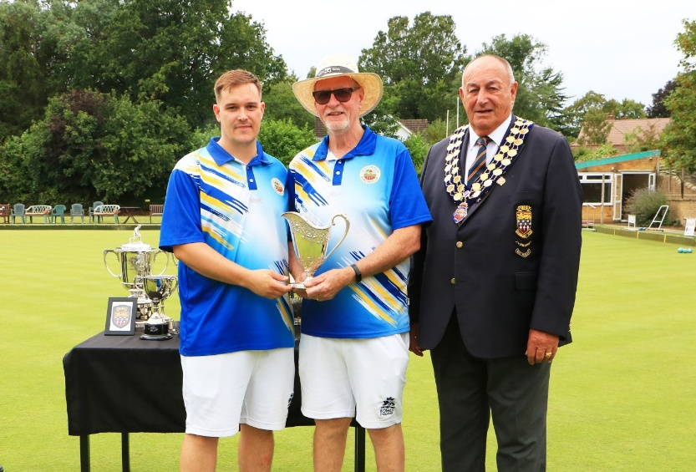 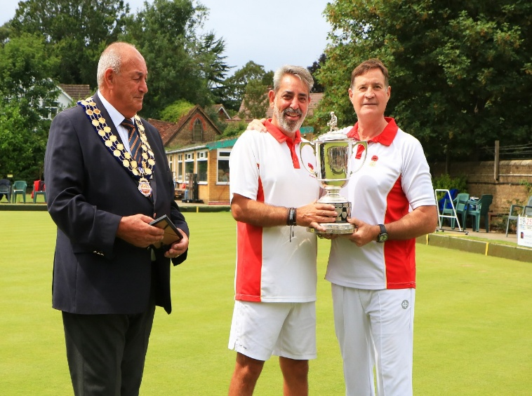 Championship Pairs finalists Championship Pairs Winners Aaron Harding & Mike Dutton – Old Coulsdon BC Wayne Kavanagh & Norman Ross - Shirley Park
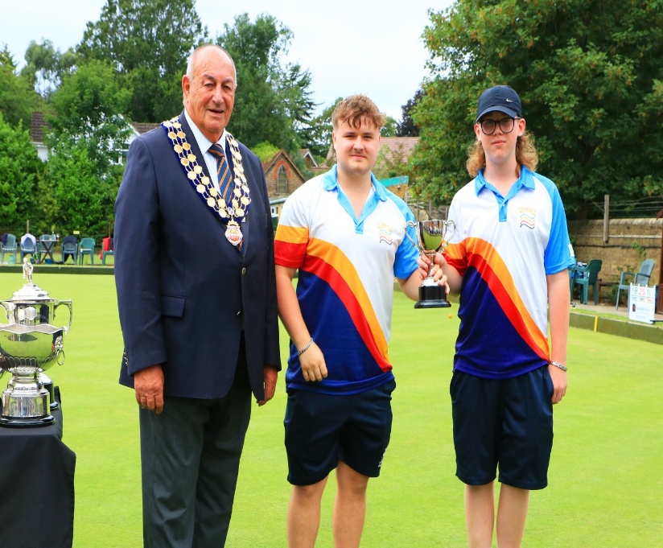 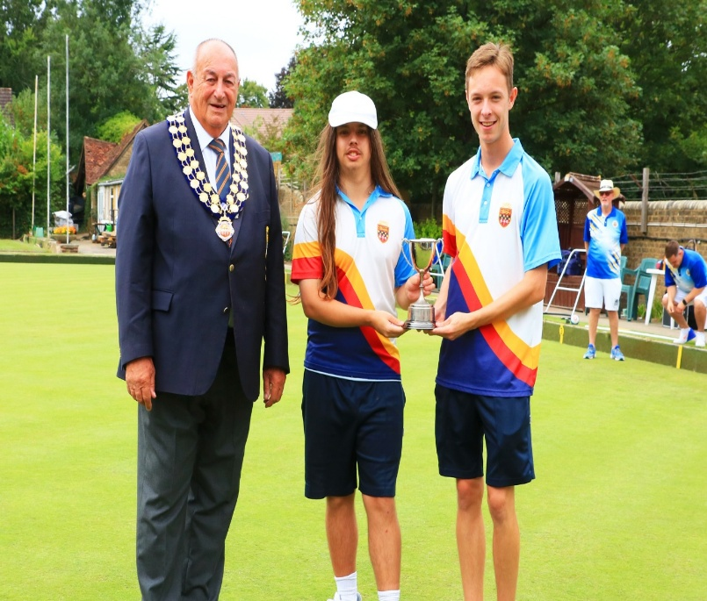Junior Pairs finalists Junior Pairs Winners
Archie Cushen – North Sheen & George Wilkins- Egham George Hopper - Chipstead & Will Vizer-Allen -Egham
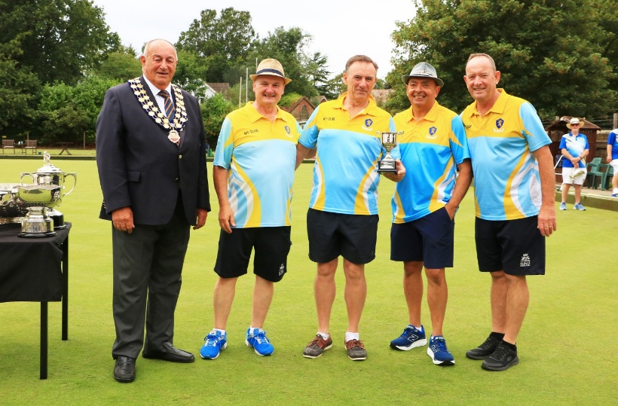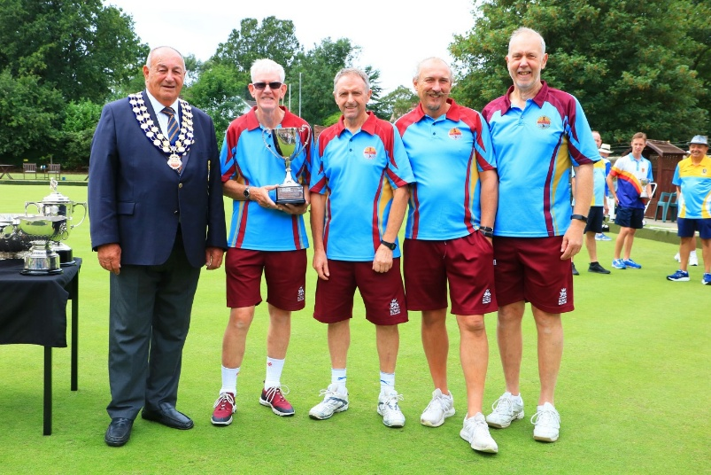
Senior Four’s finalists Senior Fours Winners
Richard Cushen, Dennis O’Mahoney, Andrew Sturton Gary Clark, Martin Sampson, Simon Greenwood
& Michael Sigamoney - North Sheen & David McCallum - Camberley
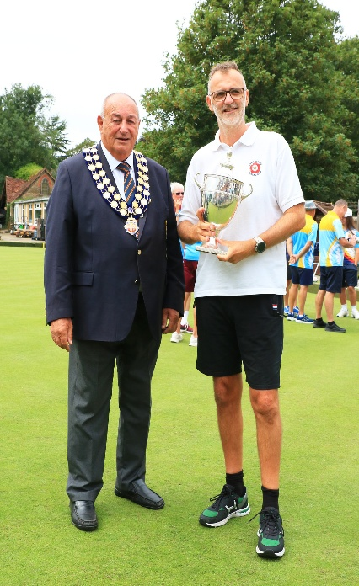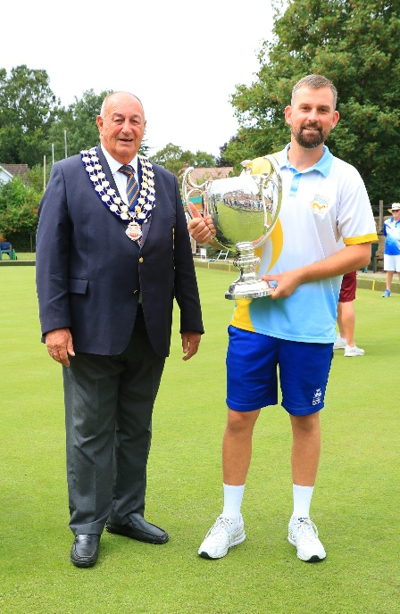
Unbadged Singles finalist – David Lyon – Ewell Village Unbadged Singles Winner – Connor Read – Ottershaw
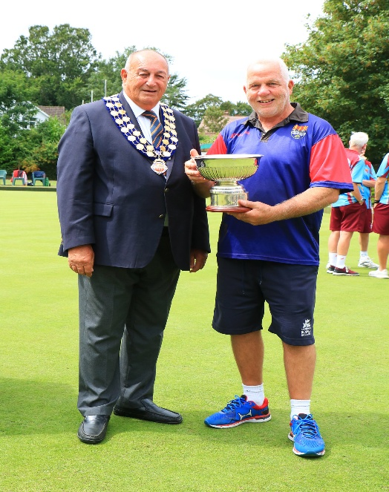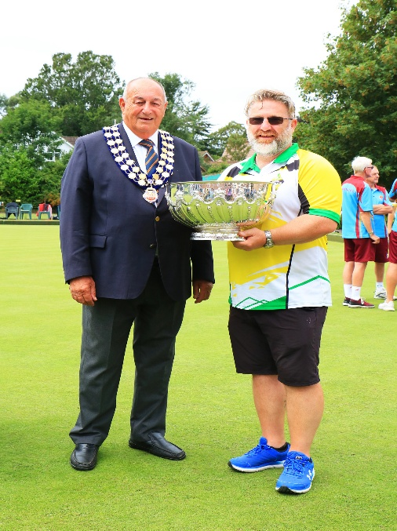
Officers Cup finalist – Don Leach – Belmont Officers Cup Winner - Mark Jones – Knaphill
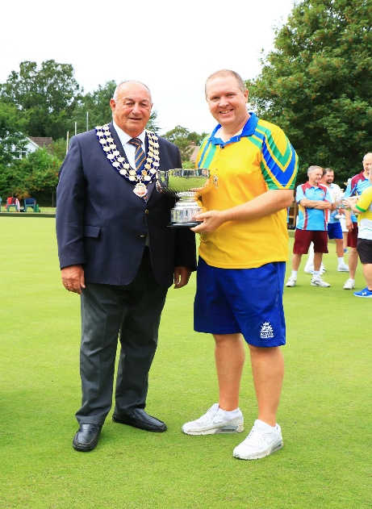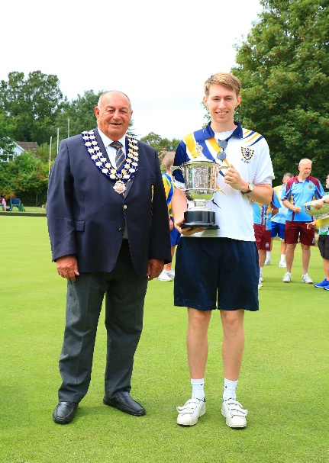
Champion of Champions finalist – Mark Bishopp - Champion of Champions Winner – James Rabson -
Egham Purley Bury

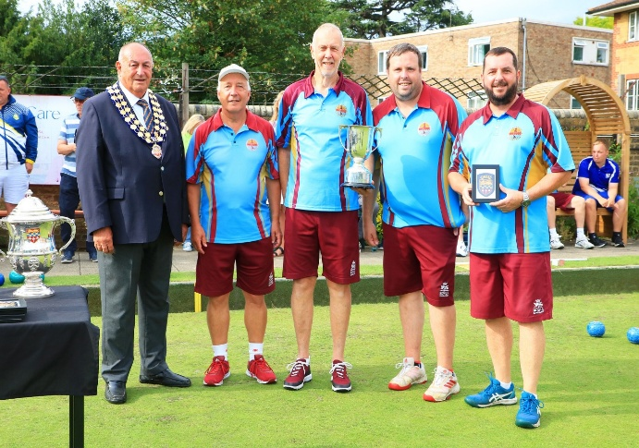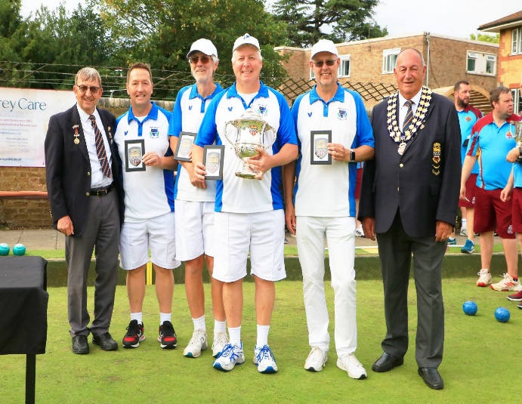
Fours finalists – Kevin Gramson, Steven Higginbotham, Fours Winners – Steve Atkin, Lee Clark, Martin Sampson & Tony Woolf – Camberley James Hamilton & John Tiller - West Byfleet
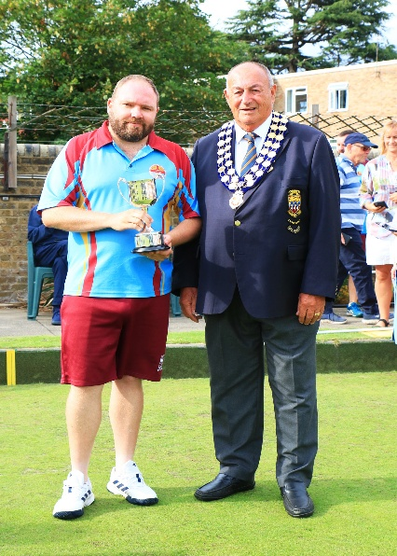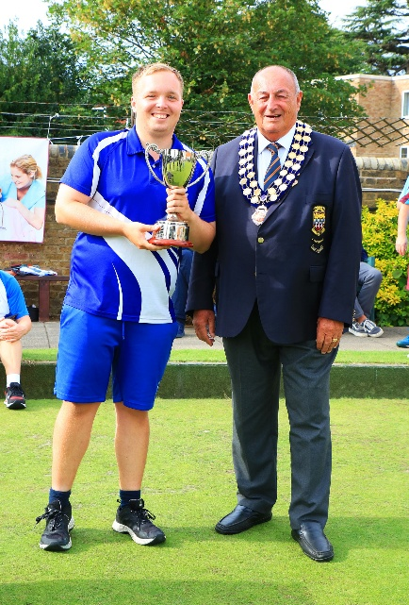
Two-Wood finalist – Terry Friday – Camberley Two-Wood Winner – Joseph Tindall - Southey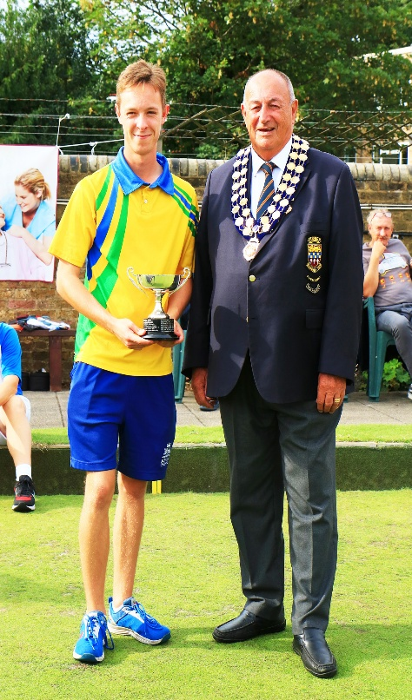 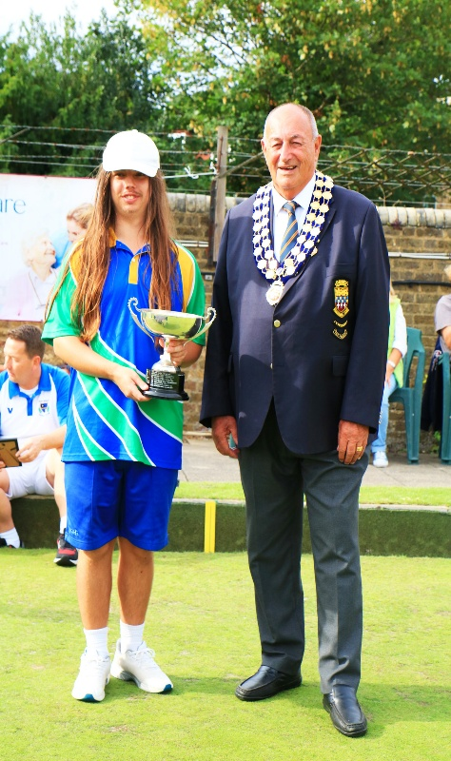
Junior Singles finalist – Will Vizer-Allen – Egham Junior Singles Winner -George Hopper - Chipstead
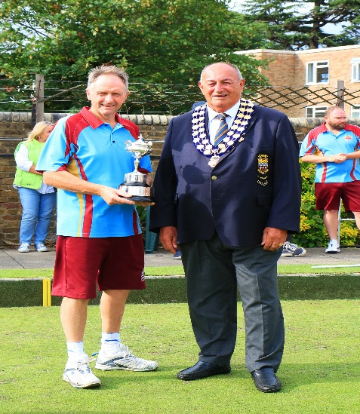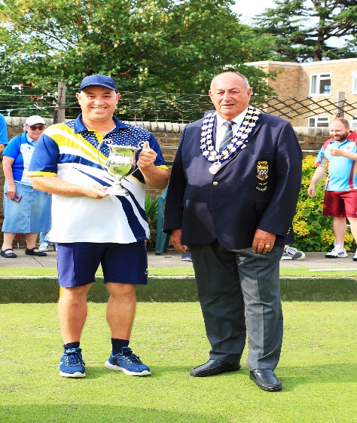
Championship Singles finalist - Gary Clark – Camberey Championship Singles Winner - Duncan Heard –
Woodbridge Hill
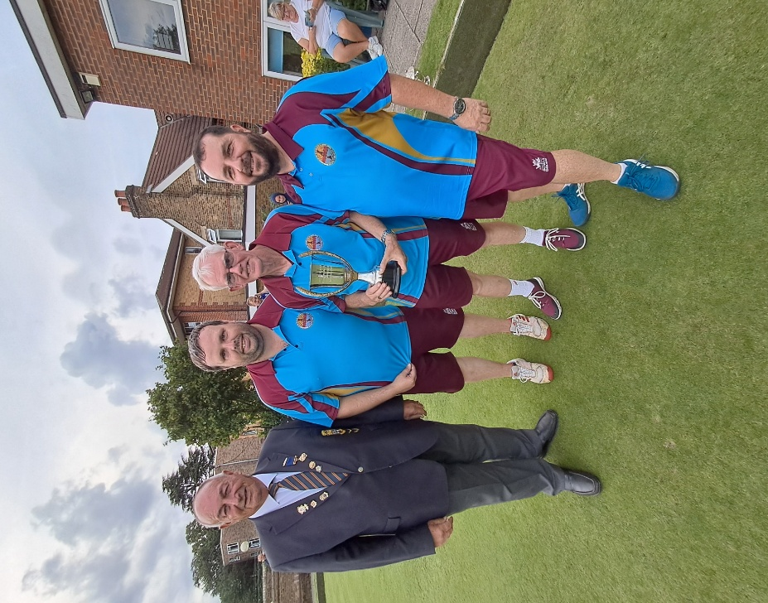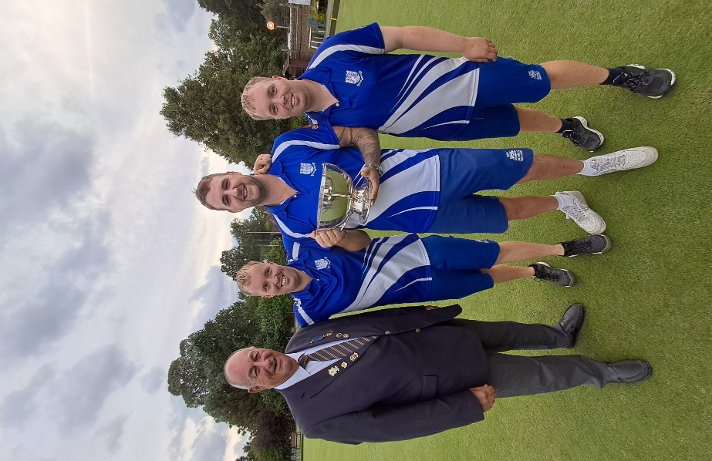
Triples finalists - Kevin Gramson, Steven Higginbotham Triples Winners - Jamie Tindall, Joseph Tindall & David McCallum – Camberley & Charlie Souter - Southey

