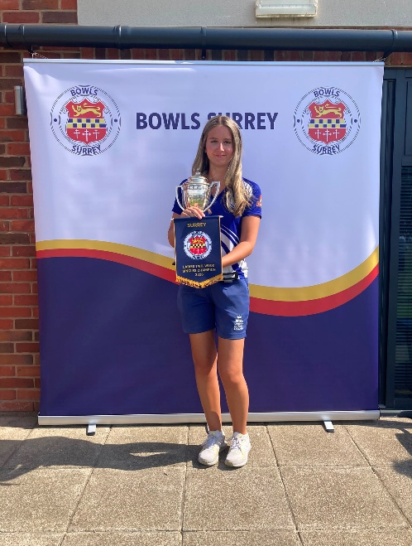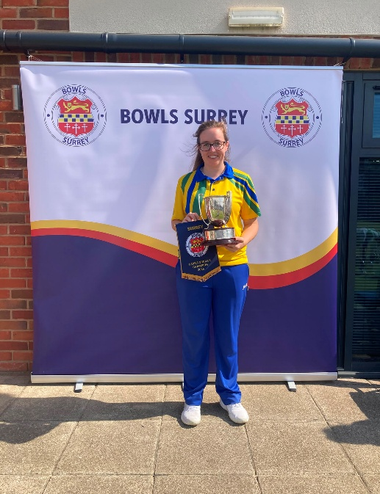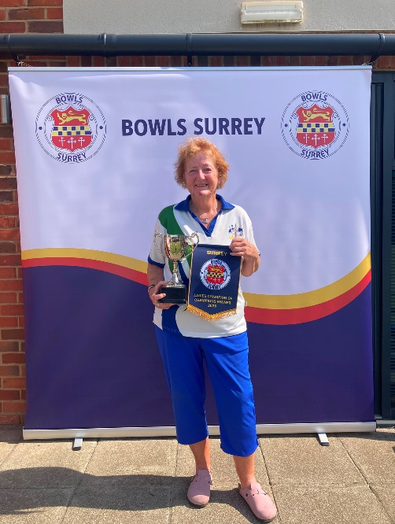
Women’s Two-Wood Singles 2026 Women’s Four-Wood Singles 2026 Women’s Champion of Champions 2026
Winner: Jemma Tuohy – Southey BC Winner: Olivia Skilton – Egham BC Winner: Carol McGrail – Sutton BC
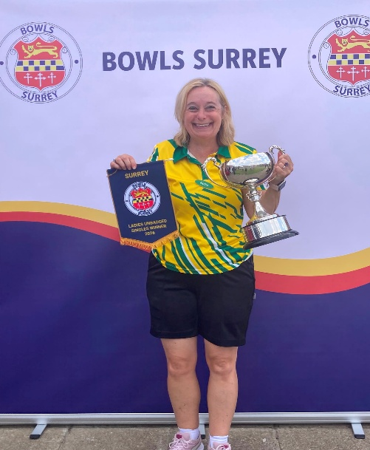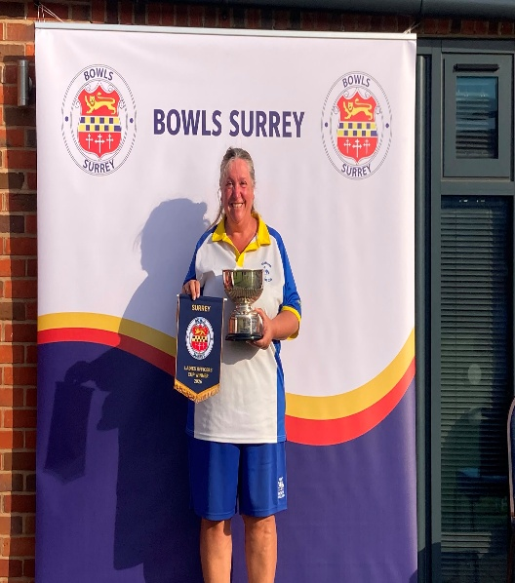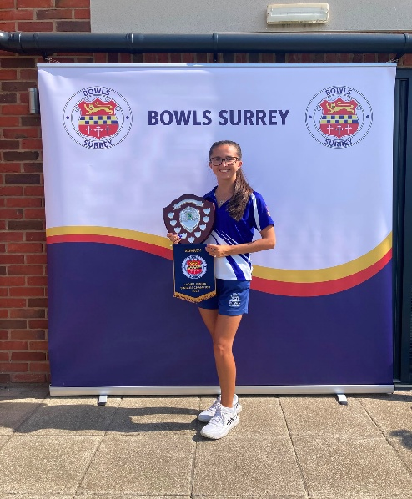
Women’s Unbadged Singles 2026 Women’s Officers Cup 2026 Women’s Junior Singles 2026
Winner: Annette Jprdan – Epsom BC Winner: Charlotte Emanuel – Cranleigh BC Winner: Yasmina Hasan – Southey BC

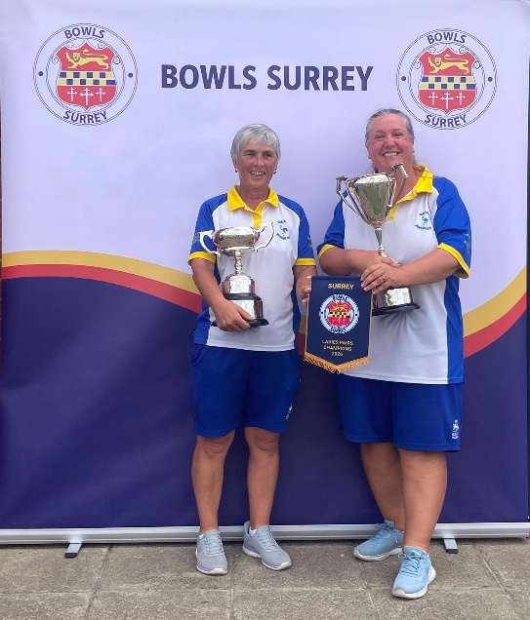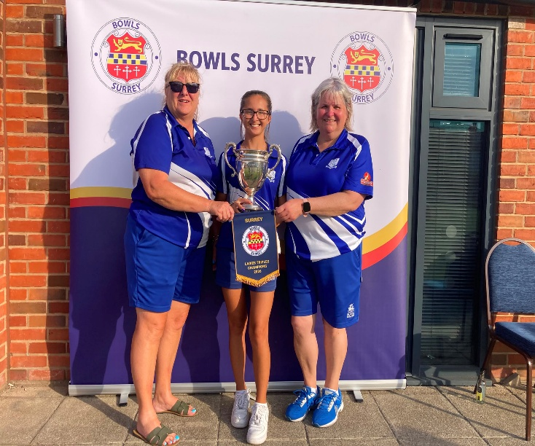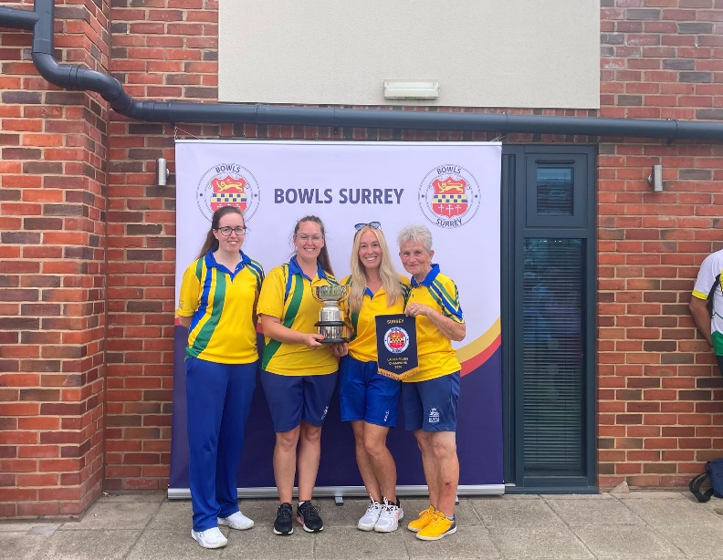
Women’s Pairs 2026 Women’s Triples 2026 Women’ Fours 2026
Winners: Cranleigh BC Winners: Southey BC Winners: Egham BC – Rachel Gingell, Olivia Skilton
Kat Hornbrook & Charlotte Emanuel Yasmina Hasan, Liz Anderson & Debbie Souter Pam Garden & Kelly Jenkins
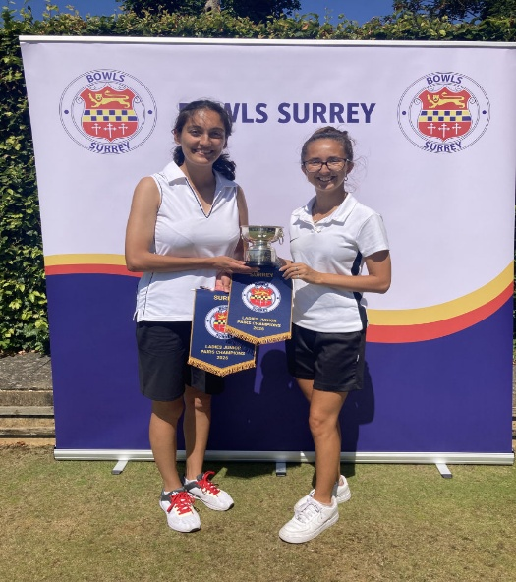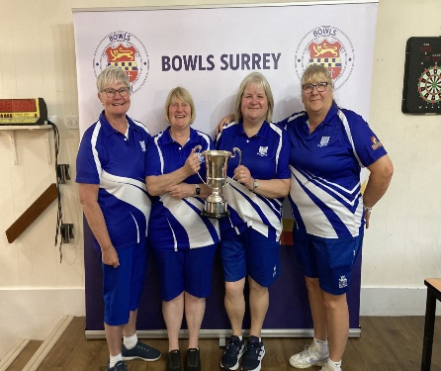
Women’s Junior Pairs 2026 Women’s Senior Fours 2026
Winners: Ava Karanth – Bletchingley BC Winners: Southey BC – Kate Capon, Shan Maylin,
Yasmina Hasan – Southey BC Liz Anderson & Debbie Souter

