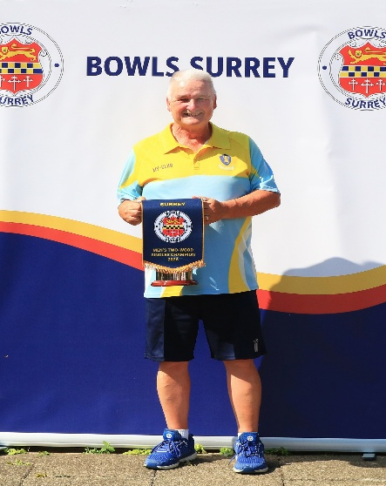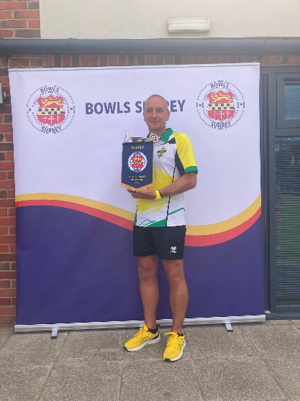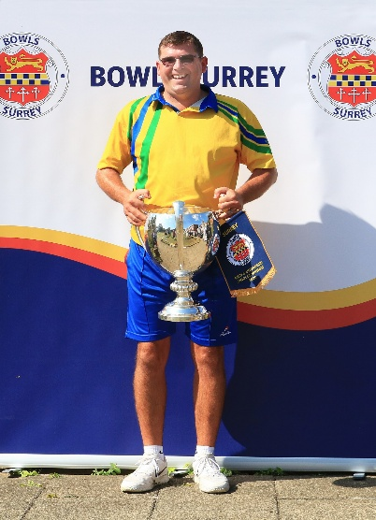
Men’s Two-Wood Singles 2026 Men’s Four-Wood Singles 2026 Men’s Unbadged Singles 2026
Winner: Richard Cushen - North Sheen Winner: Ian Jenkins – Knaphill Winner: Gary Clark - Egham
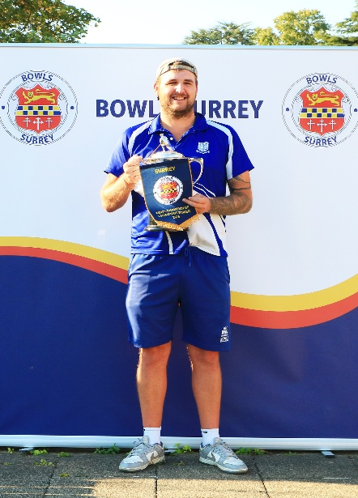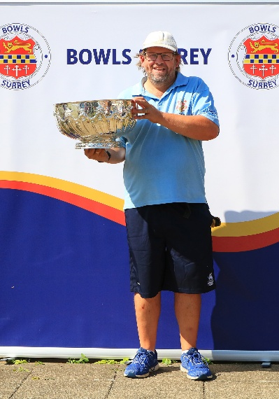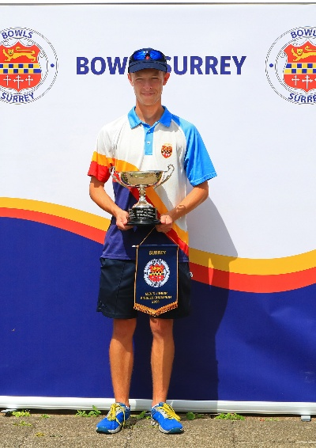
Men’s C of C 2026 Officers Bowl 2026 U24 Singles 2026
Winner: Charlie Souter – Southey Winner: Peter Staples – C.M.O. Winner: Will Vizer-Allen - Egham
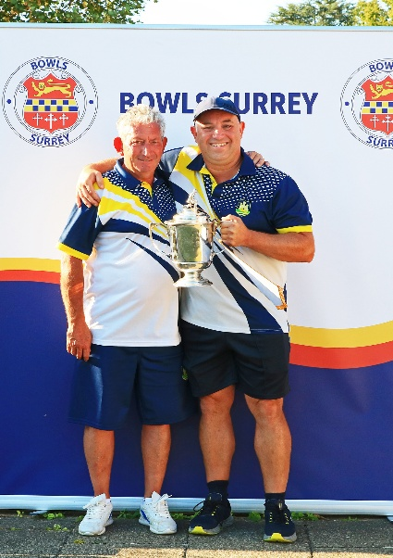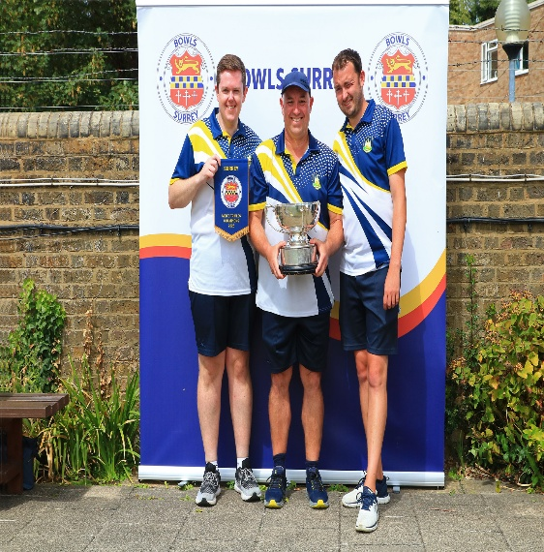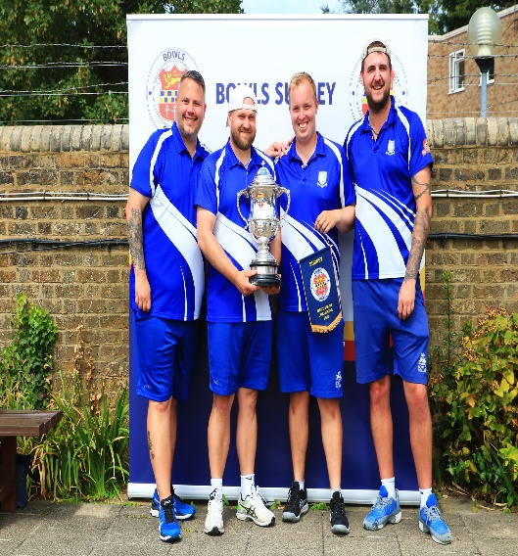
Pairs 2026 Triples 2026 Fours 2026
Winners: Duncan Heard & Winners: David Thomas, Duncan Heard Winners: Jamie Tindall, Daniel Capon
Steve Kercher – Woodbridge Hill & Jake Ladd – Woodbridge Hill Denis Hennessy & Charlie Souter –
Southey

